HOME

Welcome to Compass Driving School
Our mission at Compass driving School is to make WA roads safer for all road users by teaching students, not only the skills needed to pass their PDA (Practical Driving Assessment), but to become safe, courteous, responsible and economical drivers.
“Your mission should you choose to accept it”? To take away with you driving experience and skills that will last a lifetime.

- Patient, friendly CERT IV qualified instructor
- Manual tuition
- Air-conditioned late model dual control car
- Police clearance and Working with Children check holder
- Operating in the areas around City West, Welshpool, Midland and Morley Licensing Centres
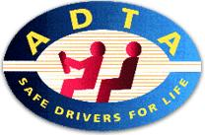Member of the Australian Driver Trainers Association of Western Australia (inc)

Vehicle

At Compass Driving School we strive to supply vehicles that are not only safe for you to train in but are environmentally friendly. We use Hyundai i30’s which utilise the latest in safety features including Front air Bags, ESP(electronic stability program), ABS(Antilock Breaking System) and active seatbelt warning alarms. AMCAP has given the Hyundai i30 model we use a 4 star safety rating. The Hyundai i30 also utilises the latest in diesel engine technology and was awarded Car of the Year and Green Car of the year in 2007 by CarsGuide.

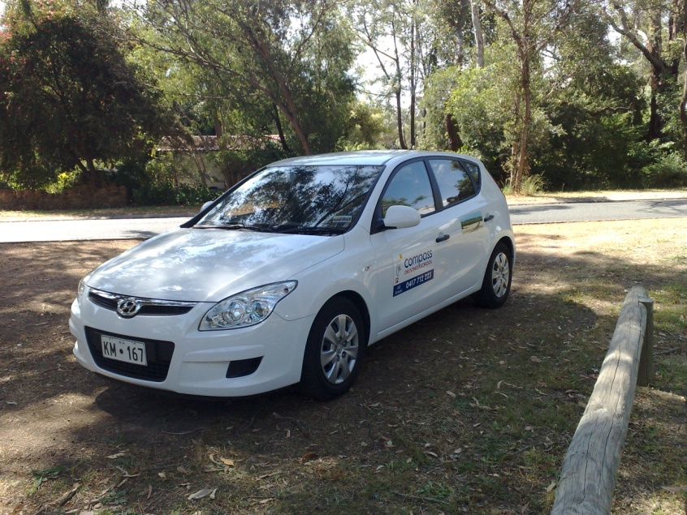

Services and costs

1 hour driving lessons (including pick up and drop off at nominated address).......................$55.00
1 hour driving lessons for overseas licence holders wishing to convert to WA drivers licence....................................................................................................................................$55.00
Lessons may be conducted in your own car when appropriate driving skill levels are reached...................................................................................................................price on application
Use of our car (including 1hour rehearsal) for PDA (Practical Driving Assessment) .................................................................................................................................................$130.00
If PDA has been booked at licensing centre outside listed areas................................................................................................................................from$150.00
If you wish to use your own car, for your PDA, accompanied by instructor ..........price on application
One of the major misconceptions is that licensing centres provide a car for the PDA they don’t. If you find that your PDA date is approaching and you do not have a car why not use ours (including pickup and drop off and rehearsal in area of nominated licensing centre)............................. from$160.00
Log book driving supervision utilising as many different driving conditions as possible (2 hour blocks including hazard perception training).....................................................................................$95.00
1 hour seniors’ refresher courses in their own car..................................................................$45.00
Gift vouchers available in blocks of 5 or 10 lessons

YOU’RE INSTRUCTOR
Barrie comes with 20 years of experience in the transport industry working as a driver, transport supervisor and work place health and safety coordinator for a major transport company. In that time he developed skills in training and induction and in all aspects of transport and logistics. He then decided that by becoming a driving instructor he could make a difference, at ground level, to the rising costs to our community, in human lives and resources, from road trauma in WA. A quote from Barrie, “I just want to teach skills and attitudes that may, one day, save a life”.

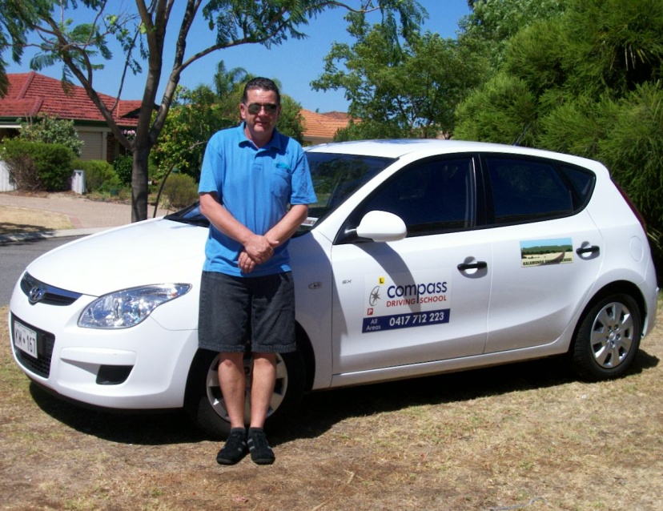

Useful Links

